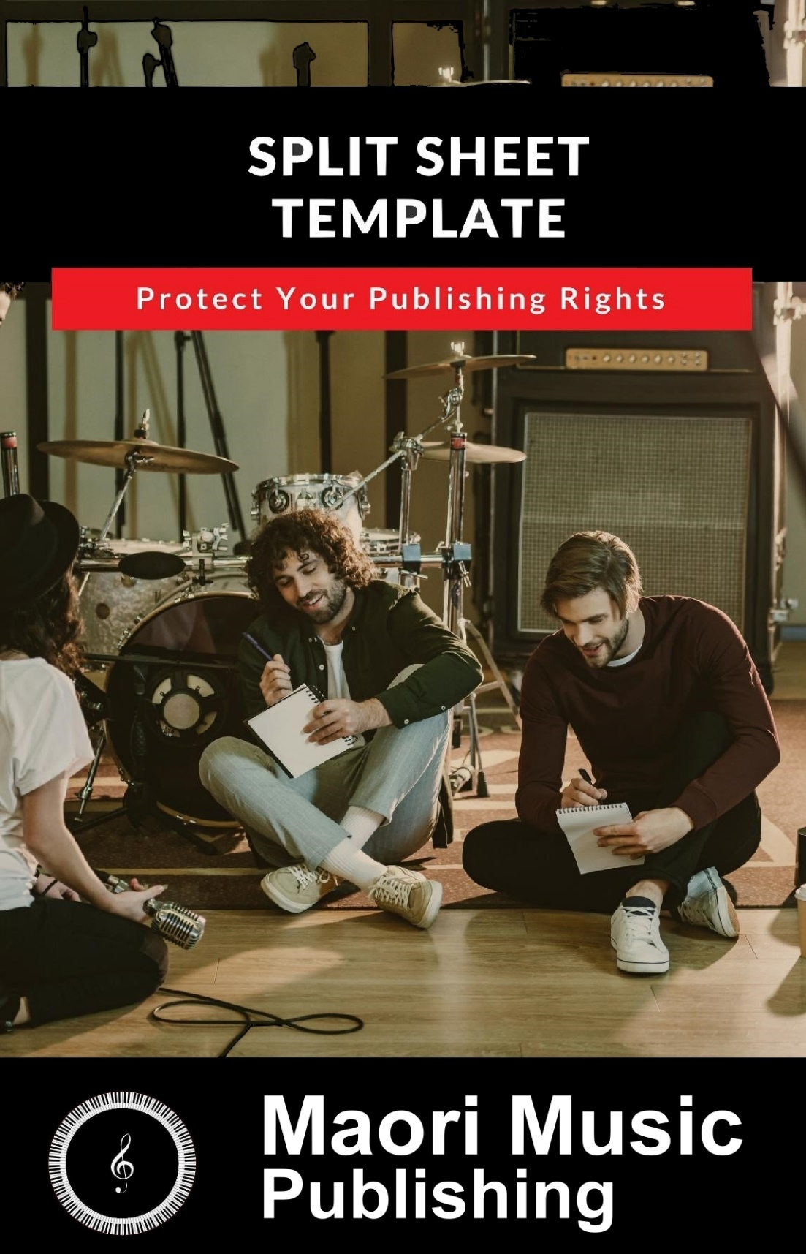

How to Use This Split Sheet

—

A Split Sheet is a document that records vital information about a song’s ownership in the case where two or more musicians work on a single song.

It captures the names, PRO aﬃliations, and contact information of all the writers involved, as well as the percentage ownership each writer has.

Properly recorded Split Sheets will protect your rights in any song that you’ve co-written so you’re sure you will get your fair share of any income that song produces, including any potential sales royalties from Downloads / CD Sales etc.

For every song you create with another writer, whether it’s in the same Band / Act or a collaboration across the Internet, fill out this sheet and keep it in your records to properly protect and document your rights.

You should send us a copy when registering any new titles that have been co-composed.

You can print and fill out as many copies of this document as you want and if you require more information about Split Sheets and Collaboration Agreements, by all means email us.
SPLIT SHEET / COLLABORATION AGREEMENT

Date:

Song Title / s :

Recording Band / Act :

--------------------------------------------------------------------------------------------------------------

Writer 1 Name :

Email:

PRO CAE/IPI No.:

Publisher (If any):

Percent Ownership of Song:

Music: Lyrics:

Sales Royalty Percentage (If Applicable) :

Writers Signature:

Writer 2 Name :

Email:

PRO CAE/IPI No.:

Publisher (If any):

Percent Ownership of Song:

Music: Lyrics:

Sales Royalty Percentage (If Applicable) :

Writers Signature:

Writer 3 Name :

Email:

PRO CAE/IPI No.:

Publisher (If any):

Percent Ownership of Song:

Music: Lyrics:

Sales Royalty Percentage (If Applicable) :

Writers Signature:

Writer 4 Name :

Email:

PRO CAE/IPI No.:

Publisher (If any):

Percent Ownership of Song:

Music: Lyrics:

Sales Royalty Percentage (If Applicable) :

Writers Signature:

Writer 5 Name :

Email:

PRO CAE/IPI No.:

Publisher (If any):

Percent Ownership of Song:

Music: Lyrics:

Sales Royalty Percentage (If Applicable) :

Writers Signature:

Writer 6 Name :

Email:

PRO CAE/IPI No.:

Publisher (If any):

Percent Ownership of Song:

Music: Lyrics:

Sales Royalty Percentage (If Applicable) :

Writers Signature:

Next Steps?

—

Hopefully you’ll find this Split Sheet template useful as you continue to co-write songs, and you can move forward into your songwriting career confidently knowing that your songs are protected.

You should now REGISTER all songs with Maori Music and we’ll take care of all the formalities associated with putting in place the process for collecting any royalties due to you.

As a songwriter, there are a lot of other avenues and opportunities you can pursue, but perhaps the most lucrative in today’s music industry is Sync Licensing.

More and more, music supervisors, filmmakers, game developers, app developers, and ad agencies are looking for awesome indie music to license for their productions.

If licensing your music is something you’d like to explore - or something you already do that you’d like to expand – please see our Sync Promo services on our website.

Looking forward to being of assistance!

